THE REAL SCHOOLS
LEARNER’S EMPOWERMET ACTIVITIES
P.5 TERM 1 2025 SCIENCE
POULTRY KEEPING

KEEPING POULTRY




Makindye Junior School

Golden Junior School

Victoria. A. Primary School

Approved by:
………....….
QC

Name: ________________________________ Class: __________
School: ________________________________Stream:_________

Theme: Science in human activities and occupation
Topic: Keeping poultry and bees
Learning outcome: The learner develops awareness and gets equipped with the survival skills of keeping poultry and bees as a viable livelihood activity.
Background knowledge: rabbit diseases.
Relevance: The learner understands poultry diseases, parasites and record keeping.
Competences: the leaner understands;
Poultry diseases, poultry parasites, poultry management practices, endo parasites, ecto parasites, record keeping.
- Key learning principle
Parasites; living organisms which depend on other living organisms for food and shelter.
Diseases; an illness that effects the proper functioning of the body.
- Learner’s centered approach; Identify any two signs of sickness in birds
- Functioning of the body.
- Poultry management practices are routine activities that a poultry farmer carries out to maintain good production.
- Ecto parasites; parasites that attack birds from outside the body.
- Endo parasites; parasites that attack the birds from inside the body.
- Record keeping; is the keeping of information regarding the farm activities.
Content:
Poultry diseases and parasites.
- Poultry diseases
Diseases in poultry are caused by; Viruses, bacteria, protozoa.
Factors that promote the spread of diseases in a poultry farm are;
Over crowding
poor feeding,
poor housing,
contaminated water and feeds.
In units, discuss and write any three examples of poultry diseases.
- Examples of poultry diseases.
Coccidiosis, fowl pox, fowl typhoid, Newcastle disease, umbrow, black head.

- A table showing details of common poultry diseases.
Disease | Signs and symptoms | Prevention and treatement
Fowl typhoid | Yellowish or green  diarrhea, rough feathers | Vaccinate regularly.  Burn and burry dead birds  Keep poultry house well  ventilated
Pnueminia | Coughing, loss of appetite  Difficulty in breathing | Keep the poultry house clean  Isolate the sick ones  Treat early with antibiotics
Fowl pox | Difficulty in breathing  Moulting and shedding  feathers  wounds in the mouth | Routine vaccination  Practice good hygiene  Add antibiotic in drinking water
Newcastle disease | Green diarrhea  Coughing and sneezing  Sneezing  Lameness | Vaccinate birds regularly  Keep the mouse clean  Application of quarantine
Gumbro disease | Ruffled feathers  Drooping of the wings  Rough feathers. | Separate the infected birds from  the healthy ones.  Burn dead birds
Parasites in poultry.
A parasite is a living organism which depends on other living organisms for food.
- Types of parasites
Ecto parasites (external parasites) and endo parasites (internal parasites)
Ecto parasites (external parasites) in poultry
These are parasites that attack birds from outside the body
Examples of ecto parasites
Chicken lice, depluming mite, fleas, red mites, jiggers,
- Diagram showing chicken lice, flea, mite and jigger
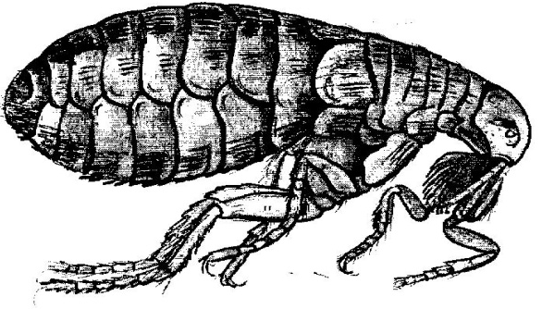 | 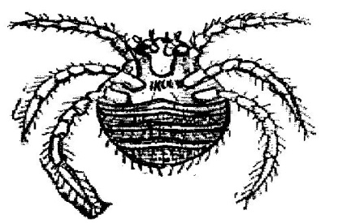 | 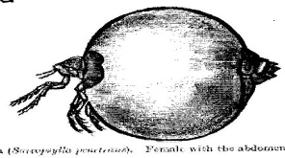

- Prevention of parasites
By dusting the birds using pesticides. -Ensure good hygiene in poultry house.
Putting oil on combs to control fleas. -Dipping the birds feet in kerosene to kill flea.
- Endo parasites
These are parasites that attack the birds from inside the body.
- Examples of endo parasites in poultry.
Tape worms, round worms, hook worms.
Signs of endo parasites.
White chalky droppings, watery diarrhea, fewer eggs are laid.
Prevention and control of endo parasites. -Deworm the birds regularly
Observe good hygiene in the poultry house. -Regular cleaning of troughs
Feed poultry on clean feeds and water.
- Effects of diseases and parasites to poultry.
They affect growth of birds. -They affect eggs production of layers
They cause illness like aneamia -They affect profit and income from poultry farming
They affect the quality of birds products.
Hands on activity
1. Give any three viral diseases which attack poultry.
i) ______________________ ii) ________________________ iii) ______________________
2. Write any three ways of controlling bacterial diseases.
i) ___________________________________________________________________________
ii) __________________________________________________________________________
iii) __________________________________________________________________________
3. Mention any two examples of endo parasites.
i) ______________________________________ ii) __________________________________
4. Give any three effects of diseases and parasitic to poultry.
i) ___________________________________________________________________________
ii) ___________________________________________________________________________
5. What are ecto parasites?
_____________________________________________________________________________
6. State any three examples of ecto parasites.
i) ___________________________________________________________________________
ii) ___________________________________________________________________________
iii) __________________________________________________________________________
7. Give any two ways of controlling ecto parasites.
i) ___________________________________________________________________________
ii) ___________________________________________________________________________

- poultry management practices.
These are routine activities that poultry farmer carries out to maintain good production e.g debeaking, deworming and dusting, egg collection, dulling, record keeping, changing litter, treating sick birds.
- Record keeping
This is the keeping of information regarding the farm activities.
- Farm records;
This is the written information about daily activities carried out on a farm
- Examples of farm records
Health records, feed records, marketing records, breed records, income and expenditure, profits and loss records, production records, sales and expense records,
- Advantages of keeping farm records
They help the farmer to know the progress on the farm.
They help a farmer to budget for the farm -They help a farmer to be taxed fairly.
They help the farmer to know the expenditure on the farm.
They help the farmer to avoid repeating mistakes.
- Terms used in poultry rearing
Hen; an adult female chicken
Cock; an adult male chicken.
Cockrel; young male domestic fowl
Pullet; immature female domestic fowl
Moulting; process by which birds shed their feathers to replace them
- Mega activity
1. Give any three reasons why poultry should be provided with a house.
i)____________________________________________________________________________
ii) ___________________________________________________________________________
iii) __________________________________________________________________________
2. State any two ways how the following poultry vice can be controlled
i) cannibalism ________________________________________________________________
ii) egg eating _________________________________________________________________
3. Identify the types of feeds given to the following poultry,
i) chick_______________________________ ii) layers ______________________________
4. How is keeping records useful on a poultry farm? (give 3)
_____________________________________________________________________________
5. What are farm records?
_____________________________________________________________________________
6. How is culling important in poultry management
_____________________________________________________________________________
7. Name any two diseases that attack both poultry rabbits.
i) ____________________________________ ii) ____________________________________
8. In which way are preachers important in a poultry house?
_____________________________________________________________________________
9. How can a farmer control ecto parasites?
_____________________________________________________________________________
10. Define the term deworming.
_____________________________________________________________________________
11. Why should eggs be collected 2 to 3 times a day?
_____________________________________________________________________________
12. Mention any two signs of worms.
i) ___________________________________ ii) _____________________________________
13. Why are tape worms regarded as endo parasites?
_____________________________________________________________________________
- SESSION TWO
Background knowledge; types of insects
Relevance: the learner understands terms used in bee keeping, groups of insects, types of bees and characteristics of each type of bees.
Competences: The learner understands;
Terms used in bee keeping, groups of insects, types of bees, characteristics of each type of bees, duties of a worker bee, uses of propolis.
- Bee keeping is keeping and management of bees
- An apiary is a farm of bees.
- An apiarist is a bee keeper.

- Social insects.
These are insects that live and work together.
- Examples of social insects.
Termites, red ants, wasps, blackants, safari.
Solitary insects
These are insects that do not live, move and work together.
- Examples of solitary insects.
Mosquitoes, houseflies, butterflies, grasshoppers, dragon flies, cockroaches.
NB: There are two groups of bees ie;
Solitary bees, bumble bees, social bees, honey bees.
- Reasons why people keep bees.
Honey can be sold to get money -Honey is used to sweeten tea and bread
Bees pollinate flowers. -Bees provide honey to man.

diagram showing external parts of a bee.
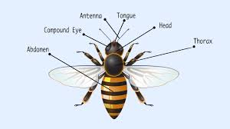

Pollen basket

- Types of bees
Queen bee, drone bee, the worker bee.
- The queen bee
It is a female bee in the hive.
- Characteristics of a queen bee
It has a long abdomen and long legs. - It is the largest bee in a hive. -It has a sting.
It has an ovipostar used for laying eggs.
It has longer legs compared to other types of bees.

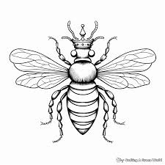
Diagram showing a queen bee

- functions of a queen bee in the hive
to lay eggs in a hive -it uses and ovipositor to lay eggs.
- The drone bee
This is a male bee in the hive.
- Characteristics of a drone bee
It is the second largest bee in a hive. - They are stout in shape.
They make buzzing sound when flying
It is the only bee without a sting in the hive -They do not work.
- A diagram showing a drone bee.
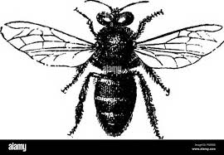

NB: The function of a drone bee is to mate and fertile the eggs of a queen bee.
The worker bee
These ate the sterile female bees in a hive.
Sterile ,means they are unable to produce or lay eggs.
- Characteristics of the worker bee.
They are the smallest type of bees in the hive -They are the busiest bees in a hive.
They are many in number. -They have a sting used for defense
They have pollen basket on their hind leg.
They cannot lay eggs and do not have ovipositor
- A diagram showing a worker bee.
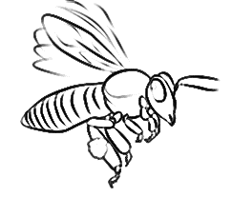

- Hands on activity
1. What are ecto parasites?
_____________________________________________________________________________
2. State any three examples of ecto parasites.
i) ___________________________________________________________________________
ii) ___________________________________________________________________________
iii) __________________________________________________________________________
3. Give any two ways of controlling ecto parasites.
i) ___________________________________________________________________________
ii) ___________________________________________________________________________

4. Mention any three characteristics of a drone bee.
i) ___________________________________________________________________________
ii) ___________________________________________________________________________
iii) __________________________________________________________________________
5. State any three characteristics of a drone bee
i) ___________________________________________________________________________
ii) ___________________________________________________________________________
iii) _________________________________________________________________________
6. State the three types of bees.
i) _____________________ ii) ______________________ iii) _________________________

7. Mention any three characteristics of a queen bee.
i) ___________________________________________________________________________
ii) ___________________________________________________________________________
iii) __________________________________________________________________________
- Duties of a worker bee
Worker bees clean the hive - They feed the brood (grub)
They feed queen bee on royal jelly -They collect nectar, water and pollen grains.
They look for a new hive.
- Uses of propolis.
It is used to smoothen the interior of a hive. -It is used to water proof the brood cells.
It is used to repair the cracks in the hive.
NB: Worker bee feed on pollen
They use proboscis to collect nectar.
- Mega activity
1. State the role of a queen bee in a hive.
_____________________________________________________________________________

2. Name the special food fed on by the queen bee.
_____________________________________________________________________________
3. Identify the following types of bees in a hive.
i) male bee in the hive
_____________________________________________________________________________
ii) male sterile ________________________________________________________________
4. What is the role of a drone bee in a hive?
_____________________________________________________________________________
5. Why do people keep bees? (give three)
_____________________________________________________________________________
6. Name the type of bees shown below.

7. Mention any three uses of propolis.
i) ___________________________________________________________________________
ii) __________________________________________________________________________
iii) _________________________________________________________________________
8. Give any three duties of a worker bee.
i) ___________________________________________________________________________
ii) __________________________________________________________________________
iii) __________________________________________________________________________
9. What does a queen bee use to lay eggs?
_____________________________________________________________________________
10. What name is given to a sterile female bee in a hive?
_____________________________________________________________________________
11. Where does a queen bee lay its eggs?
_____________________________________________________________________________
12. Why does a drone bee die after mating with a queen bee?
_____________________________________________________________________________
13. Mention any two examples of;
a) social insects _______________________________________________________________
b) solitary bees _______________________________________________________________
14. State any three duties of a worker bee
i) ___________________________________________________________________________
ii) __________________________________________________________________________
iii) __________________________________________________________________________
15. Mention any two uses of propils.
i) ___________________________________________________________________________
ii) ___________________________________________________________________________

- SESSION THREE
Background knowledge; metamorphosis
Relevance; the learner understands the lifecycle of honey bee, fertilization, in bees, conditions for swarming and types of bee hives.
Competences: The learner understands;
Life cycle of bees, fertilization of bees, swarming of bees, reasons for swarming, bee hives, types of bee hives, local bee hives, modern bee hives, natural bee hives, methods of harvesting honey, steps of harvesting honey.
- Key learning principle
Lifecycle; stages of development of an insect undergoes.
Wedding; flight during which the drone bee mates the queen bee.
Swarm; a group of bees.
Swarming; is the movement of bees from one place to another looking for new home.
A hive; an endorsed structure in which bees live
Natural bee hives; these are not man-made hives.
Modern bee hives; these are properly made bee hives with all the necessary parts and chambers.
Harvesting honey; the removal of honey from the bee hive.
Learners centered approach; state two signs of growth in living things
- Content
- Lifecyle of a honey bee
Bees undergo a complete lifecycle ie eggs-larva-pupa-adult.
Queen bee lays fertilized eggs which change to larvae (grubs) pupae them to adult bees.
The larvae feed on royal jelly for the first two days and from the third day they are fed on honey and pollen grains.+
- Diagram showing life cycle of honey bees.
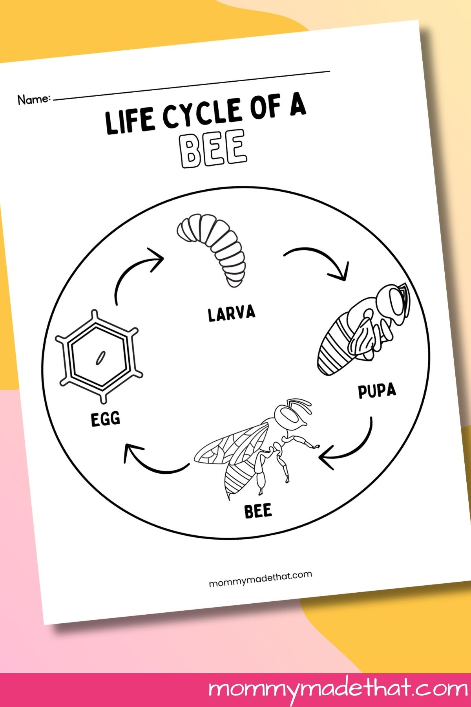

Note: The eggs of different types of bees take different duration to develop into adults.
Queen takes 15 days, drone bee takes 24 days and worker bee takes 21 days.
- Fertilization in bees
- The virgin queen bee mates with a drone during the nuptical fight.
Wedding/mating/ maiden fight.
- This is a flight during the drone bee mates the queen bee.
- Mating occurs in flight.
- The queen may mate with a number of drones on one flight.
Why does the drone bee die after the wedding flight.
- Due to damage of the abdomen caused by loss of its reproductive organ during mating.
Its abdomen rips open as the pennis is ripped out of its body and remains attached to the queen during mating.

- Swarming in bees
A swarm is a group of bees.
Swarming is the movement of bees from one place to another looking for a new home.
- Reasons for swarming.
To search for a new home. For the queen to make
- Conditions for swarming to take place
Overcrowding of bees in the hive -When another queen bee is produced in the hive
When a queen bee dies. -Due to bad smell near the hive or inside the hive.
Due to direct sunlight into the hive. - Dampness in the hive.
Direct sunlight into the hive. -Lack of proper ventilation.
bee hives
a hive is an enclosed structure structure in which bees live
- types of bee hives
modern bee hives, local/traditional bee hives, natural bee hives.
- Local/ traditional bee hives
These are locally made bee hives e.g Dug out log bee hive, Kigezi bee hive, tin hive.
- Kigezi bee hive
These are woven using reeds and soil mixed with cowdung
- Dug out log hive
This is made from a log of a big tree.
Tin hive;
This is made out of a big tin
Diagrams to show traditional bee hives.
Kigezi bee hive | Dug out log hive | Tin hive
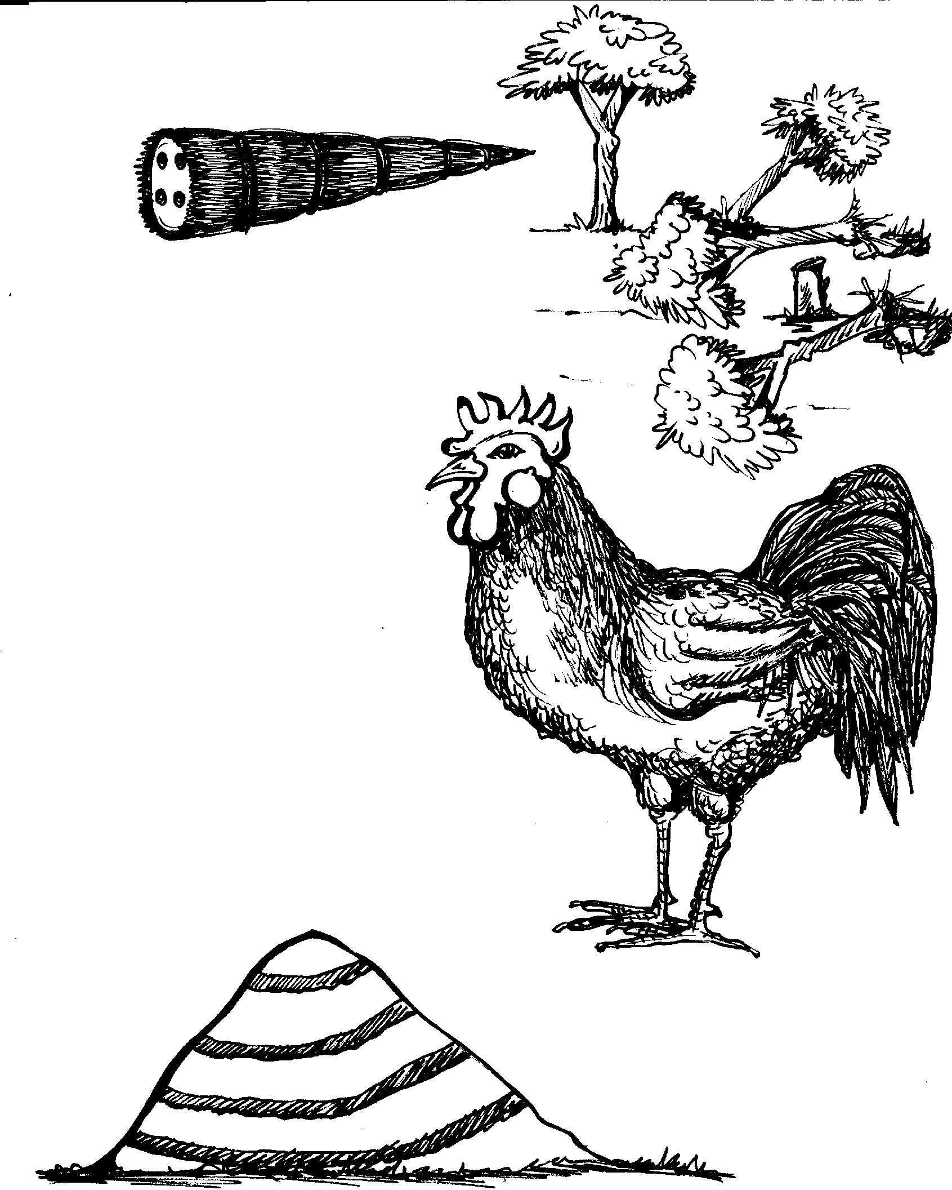 | 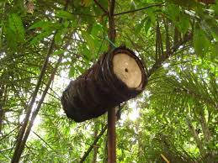 | 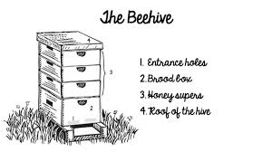

A

advantages of traditional/local bee hives
They are easy to make. -They are made from locally available materials.
They are cheap since a farmer can easily make them.
The bees are non-constantly distributed by the bee keepers.
- Disadvantages of local bee hives
They can easily be destroyed -There colony cannot be inspected.
They last for a short time -The hive is damaged in the process of harvesting honey.
It is not easy to harvest honey from the
- Mini activity
1. Apart from bees, mention any two other insects which under go complete metamorphosis
i) __________________________________ ii) ______________________________________
2. What name is given to a flight during which the done bee mates the queen bee?
_____________________________________________________________________________
3. Mention the three examples of local hives.
i) _____________________ ii) _______________________ iii) ________________________
4. State any three advantages of traditional bee hive.
i) ___________________________________________________________________________
ii) ___________________________________________________________________________
iii) __________________________________________________________________________
5. What is swarming?
_____________________________________________________________________________
6. Write any one reason why bees swarm.
_____________________________________________________________________________
7. Mention any three conditions for swarming.
i) _________________________ ii) ______________________ iii) _____________________

- natural bee hives
these are not man-made bee hives e.g tree trunks, anthills, rockholes, holes in the ground.
- Modern bee hives
These are properly made bee hives with all the necessary parts and charcoal e.g top bar hive, box hive.
- Diagram to show modern bee hives.
Top bar hive | Box hive
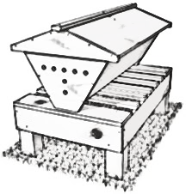 | 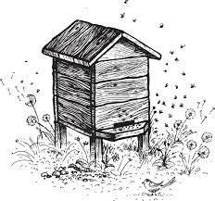
- Diagram showing the internal structure of a modern bee hive.
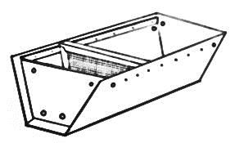

- Importance of parts of modern bee hives
The brooder; it is where the queen bee lays eggs., it contains the following eggs, larva, pupa, and young bees.
The honey chamber; this is where the worker bees keep honey and pollen.
The queen excluder; this is a metal with small hole put inside a hive, it prevents the queen from laying eggs in the honey chamber.
The holes; these allow worker bees to get in and out as they prepare honey.
- Advantages of a modern bee hives
The hive can easily be inspected 0-Harvested honey is always clean.
Top bar hives is durable
Only the honey comb which are ready can be harvested.
- Disadvantages of modern bee hives.
They are expensive to make.
- Harvesting honey
Honey harvesting is the removal of honey from the hive.
NB: The best time for harvesting honey is the evening when the weather is cool.
- Methods of harvesting honey.
Traditional methods, modern methods
NB; The hive is lowered on the ground during honey harvesting to prevent damaging the combs
Cut and remove combs from the top to the bottom
Avoid billing killing the bees.
Leave some old combs for the bees to suck honey.
NB; Ensure that some combs with honey remain in the hive for bee to feed on before they build new ones.
- Mega activity
1. What is metamorphosis?
_____________________________________________________________________________
2. What name is given to the larva stage of bees?
_____________________________________________________________________________
3. How many days does a queen bee take to develop into adults?
_____________________________________________________________________________
4. Differentiate between swarming and a swarm.
________________________________________________________________________________________________________________________________________________________
5. Write any three conditions of swarming in bees.
i) _________________________ ii) ______________________ iii) _____________________
6. Apart from modern bee hives, mention the two other type of bee hive.
_____________________________________________________________________________
7. Which hive is shown below.

________________________________________________________

8. Mention any 2 examples of modern bee hives.
i) ___________________________________ ii) _____________________________________
9. Give any two advantages of modern bee hives.
i) ___________________________________________________________________________
ii) ___________________________________________________________________________
10. Why is the queen excluder made off up of small wire mesh?
_____________________________________________________________________________
11. Define harvesting honey.
_____________________________________________________________________________
12. Why is a hive lowered on the ground during harvesting?
_____________________________________________________________________________
13. Write any five steps for harvesting honey.
i) ___________________________________________________________________________
ii) ___________________________________________________________________________
iii) __________________________________________________________________________
iv) __________________________________________________________________________
v) ___________________________________________________________________________
14. The diagram below shows the internal structure of a modern bee hive. Study it carefully and answer the questions that follow.

B
A

C

15. Write the importance of the following parts
a) The blood chamber, _________________________________________________________
b) the queen excluder _________________________________________________________
16. Give the disadvantage of modern bee hives.
____________________________________________________________________________
- SESSION FOUR
Background knowledge; steps of harvesting honey
Relevance; The learner understands the equipment used when harvesting, extraction of honey, stocking a hive and examples of bee baits.
Competence; The learner understands
Equipment used when harvesting honey, extraction of honey, floating the wax method, configuring method, care and management of bees siting the bee hive,
Factors to consider when siting the hive, stocking a hive, ways of stocking bees, advantages of bee keeping, bees products, uses of bee wax, bees enemies.
- Key learning principle,
Equipment: tools
Extracting honey; act of removing honey from the honey combs.
Sting the bee hive, this refers to the process of selecting suitable in which to put a hive
Stocking a hive; putting bees an empty hive to occupy it.
Content
Learner’s centered approach: State materials that are used in bee keeping
- Equipment (tools) when harvesting honey.
Beels veil; to protect the face from being stung by bees.
A bucket; for collecting honey.
A knife; used to cut honey combs
Smoker; to produce that calms down the bees.
Bee keepers gloves; to protect the hands from being stung by bees.

- extraction of honey
This is the act of removing honey from the honey comb.
- Methods of extracting honey.
- Floating the wax method,
- Pressing the honey methods; this is the method where combs are wrapped in a clean cloth and squeezed for honey to come out through the cloth.
- Centrifuging method;/spinning; this is the method of honey extraction where a machine is used to remove honey from the combs, the machine is called extractor.
- How honey is processes.
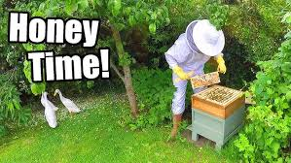

- Golden yellow combs are removed and crashed
- The crushed combs are sieved.
- The wax remains on the sieve as honey drops into a clean container under the sieve.
- Collected honey is then melted over a stream bath.
- After setting, the scum that forms on top of honey is removed using a spoon of knife.
- At this stage, honey is ready for eating
However, it can be sieved again to make it pure and give it clear colour.
- Care and management of bees
Bees can be managed through the following ways;
i) placing the hive in a good condition ii) stocking the hive iii) feeding the bees.
iv) controlling bees pests.
- Siting the bee hive
This refers to the process of selecting a suitable place in which to put the bee hive.
An apiary is a place in which a number of bee hives are kept.
- Factors to consider when siting a hive.
It should be near flowering plants It should be free from bee enemies.
It should be near flowering plants. -The place should be away from home.
If should be from noise and other disturbances.
NB: The poles on which the bee hive is hang should be smeared with oil to prevent ants from reaching the hive.
- stocking a hive
stocking a hive means putting in an empty hive to occupy it
requirements for stocking a hive/starting a colony.
Queen, e.g sugar solution, honey combs, honey banana juice, bee wax, a trough of water, to place near the hive
- How stocking is done in apiculture.
By setting a hive, putting baits and waiting for bees to occupy it on them.
By trapping bees into the hive using a swarm catching net. -Using a catcher box.
By finding a resting
- Diagrams showing a swarm catching net and catcher.
A swarm catching net | A catcher box
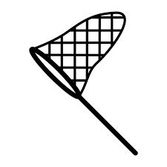 | 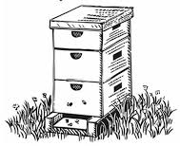
NB: The farmer uses the above swarm catcher to consider to transfer the bees trapped to the main hive.
- Advantages of keeping bees.
Apiculture takes little space. -Less labour and attention are needed.
Bee farmers get regular income from bee products.
Bees pollinate flowers.
- Importance of bee to people
Bees provide honey -Bees pollinate flowers -Provide wax to people
Propolis collected by bee wax is used as food supplement.
It is used to make local medicine
- Mini activity
1. Mention any two advantages of keeping bees.
i) ___________________________________________________________________________
ii) ___________________________________________________________________________
2. State any four uses of honey to man.
i) ___________________________________________________________________________
ii) ___________________________________________________________________________
iii) __________________________________________________________________________
iv) __________________________________________________________________________
3. Mention any five-equipment used when harvesting honey.
i) ___________________________________________________________________________
ii) __________________________________________________________________________
iii) _________________________________________________________________________
4. What is extraction of honey?
_____________________________________________________________________________
5. State the methods of extracting honey.
i) ________________________________________ ii) ________________________________
6. Describe how honey is processed in five steps.
i) ___________________________________________________________________________
ii) ___________________________________________________________________________
iii) __________________________________________________________________________
iv) __________________________________________________________________________
v) __________________________________________________________________________
7. What siting a bee hive?
_____________________________________________________________________________
8. State any three factors considered when siting an apiary.
i) _____________________ ii) ______________________ iii) ________________________
- uses of bee wax.
It is used to make candle wax. -It is used in making of shoe polish.
For making crayons used in painting -To make varnish for furniture
It is used for making floor polish.
- Products got from bee wax.
Crayons, candle wax, cosmetics, polish for shoes and floor.
- Importance of bees to plants.
Bee pollinate flowers which help to reproduce
They carry out cross pollination
- Dangers of bees
Bees sting people and cause pain.
Bees cab sting domestic animals to death.
Bees enemies and dieases
Examples of bees enemies
Honey badgers, wax moths, ants, wasps, rats, hive beetle, hawk moths.

- Ways of preventing enemies from destroying bees.
Hang the hive between poles. -Keeping grass around the hives short
Spraying insecticides at the base of the poles to kill pets.
Putting grease on the gives to prevent threats from climbing
- Diseases of bees
American fowl brood, nasema, stone brood, bald brood, European fowl brood.
- Hands on activity
1. Mention any three bees enemies
i) _________________________ ii) _______________________ iii) ____________________
2. State any two ways of preventing enemies from destroying bees.
i) ___________________________________________________________________________
ii) ___________________________________________________________________________
- mega activity
1. Write down the term used to mean the keeping of bees.
_____________________________________________________________________________
2. Which food value is got from eating honey?
_____________________________________________________________________________
3. How are bees important to plants?
_____________________________________________________________________________
4. State any two examples of bees enemies.
i) _____________________________________ ii) ___________________________________
5. How can a farmer prevent enemies from destroying bees? (give 2)
_____________________________________________________________________________
6. What can bees be fed on during drought?
_____________________________________________________________________________
7. Name the equipment used in stocking bees shown below.

_____________________________________________________________

8. How is stocking a hive different from siting a hive?
_____________________________________________________________________________
_____________________________________________________________________________
9. Write the importance of the following tools when harvesting honey.
a) overall ____________________________________________________________________
b) smoker ___________________________________________________________________
c) bucket ____________________________________________________________________
10. State any three methods of extracting honey.
i) ______________________________________ ii) __________________________________
11. Mention any three factors to consider when locating a hive.
i) _______________________ ii) ________________________ iii) _____________________
12. Give any four uses of bee wax.
i) __________________________________________________________________________
ii) ___________________________________________________________________________
iii) __________________________________________________________________________
iv) __________________________________________________________________________
13. State any two importance of bees to plants.
i) ___________________________________________________________________________
ii) ___________________________________________________________________________
14. Mention any one danger of bees.
_____________________________________________________________________________

